Year 12 Chemistry Topic Test #3 (Organic) - 2012

Name: ANSWERS Mark = _____ / 55

Part 1: Multiple Choice Section 5 marks
___________________________________________________________________________________

1. A 2. A 3. D 4. D 5. B each

Part 2: Short Answer Section 50 marks
___________________________________________________________________________________

1. Write fully balanced equations for any reactions that occur in the following procedures. If no
reaction occurs, write ‘no reaction’. Write the name of any organic product formed.

(a) The combustion of octane in excess oxygen
Equation: 2 CH₃(CH₂)₆CH₃ + 25 O₂ → 16 CO₂ + 18 H₂O

(b) Propan-1-ol is added to methanoic acid in the presence of concentrated sulfuric acid.
Equation: HCOOH + CH₃CH₂CH₂OH → HCOOCH₂CH₂CH₃ + H₂O
Name of organic product: 1-propyl methanoate
(2+2+1 = 5 marks)

2. Complete the table below by naming a reactant that will react with the reactant in column 1 to give the product in column 3.

Reactant 1 | Reactant 2 | Product formed
ethene | water | ethanol
propene | hydrogen chloride | 2-chloropropane
ethanol | propanoic acid | ethyl propanoate
butanoic acid | propan-1-ol | 1-propylbutanoate

each (4 marks)

3. Give the order of the boiling points of these chemicals, numbering them 1 to 6, with 6 being the highest value.

Compounds | Order of boiling points (1 – 6)
butan-1-ol | 5
methylpropane | 1
butanoic acid | 6
butan-2-ol | 4
butane | 2
butanal | 3
each (6 marks)
4. Use the following condensed structural formulae to answer the questions that follow:

A CH₃CH₂CH₂CH₂CH₂OH 1° alcohol

B CH₃CH(OH)CH₂CH₂CH₃ 2° alcohol

C CH₃CH(OH)CH(CH₃)CH₃ 2° alcohol

D CH₃C(CH₃)₂CH₂OH 1° alcohol

E CH₃C(OH)CH₂CH₃ 3° alcohol
|
CH₃

Choose which compounds (A, B, C, D or E) which will give each of the following reactions (there may be more than one answer in each case)

(a) Which compound(s) react with a warm solution containing sulfuric
acid and potassium dichromate to produce a carboxylic acid. A, D

(b) Which compound(s) react with a warm solution containing sulfuric
acid and potassium dichromate to produce a ketone. B, C

(c) Which compound(s) would show no visible signs of a reaction
with a warm solution containing sulfuric acid and
potassium dichromate. E
(d) Write the structure and name for the oxidation product of C with acidified potassium
permanganate.

structure CH₃COCH(CH₃)CH₃ name 3-methybutan-2-one

(e) Write the equation for the reaction between D and methanoic acid in the presence of
concentrated sulfuric acid.

CH₃C(CH₃)₂CH₂OH + HCOOH → HCOOCH₂C(CH₃)₃ + H₂O

(f) Class alcohols C and E as primary (1º), secondary (2º) or tertiary (3º)

Alcohols | Class
C | 2°
E | 3°

(11 marks)
5. Write IUPAC names for the following compounds.

Compounds | Names
CH₃CH₂COOCH₃ | methyl propanaoate
(CH₃)₃CH | methylpropane
CH₃CH(CH₃)CH₂CH₂COCH₃ | 5-methylhexan-2-one

each (3 marks)

6. Draw a piece of polymer using but-1-ene as the monomer; show 3 repeating units.

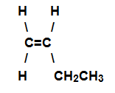

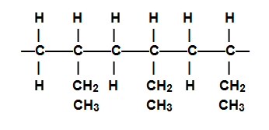 ✓✓

(2 marks)

7. An organic compound X has an empirical formula C₂H₄O.

0.0278 mol of this compound has a mass 2.45 g.

(a) What is the molecular formula of compound X? Show all working.

EFM = 44.05

M(X) = m/n = 2.45/0.0278 = 88.13 g mol⁻¹

∴ MF = 2 x EF = C₄H₈O₂

(b) Compound X has several isomers.

(i) Isomer 1 is a sweet smelling liquid which was prepared using propan-2-ol as one
of its reactants. Give structure of isomer 1.

structure 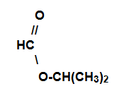

(ii) Isomer 2 is also a sweet smelling liquid but ethanoic acid was used in its
preparation. Give structure and name of isomer 2.

structure 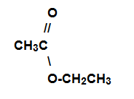 ✓

name ethyl ethanoate

(iii) Isomer 3 gives off a gas when added to solid sodium carbonate.
Give structure and name of isomer 3.

structure 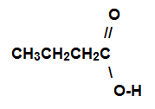 ✓

name butanoic acid

(3 + 5 = 8 marks)

8. Two α-amino acids are shown below

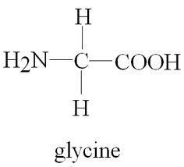 | 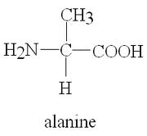

(a) A chemical is said to be amphoteric if it can react with an acid and a base.
Glycine can be classed as an amphoteric chemical.
Using equations illustrate the amphoteric property of glycine

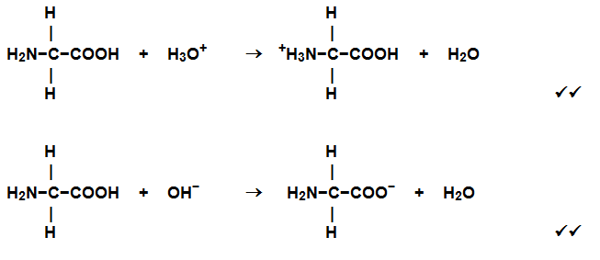

(b) Draw a piece of condensation polymer between glycine and alanine molecules.

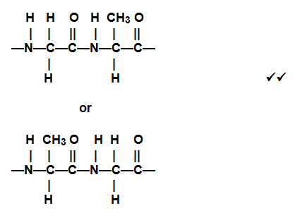

(4 + 2 = 6 marks)

9. Here is the structure of a typical saturated triglyceride fat;
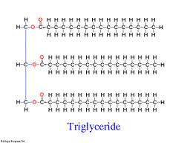

(a) What is the important functional group in this molecule? ester

(b) An important reaction of such fats and oils is hydrolysis by reaction with sodium hydroxide
solution. Draw the two main organic products of this hydrolysis.

Product 1 | Product 2
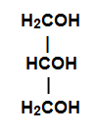  ✓ | CH₃(CH₂)₁₄COO⁻

(1,2,2=5 marks)

End of Test

